Servlet Init Params :

they are name-value pairs of texual information that are supplied to a servlet declaratively. That texual information could be a file location where you want all your uploaded files to be saved to or it could be simply the database username and password. All the values you want to pass to, are just name-value pairs.

These init params can be set using annotations or from web.xml file.

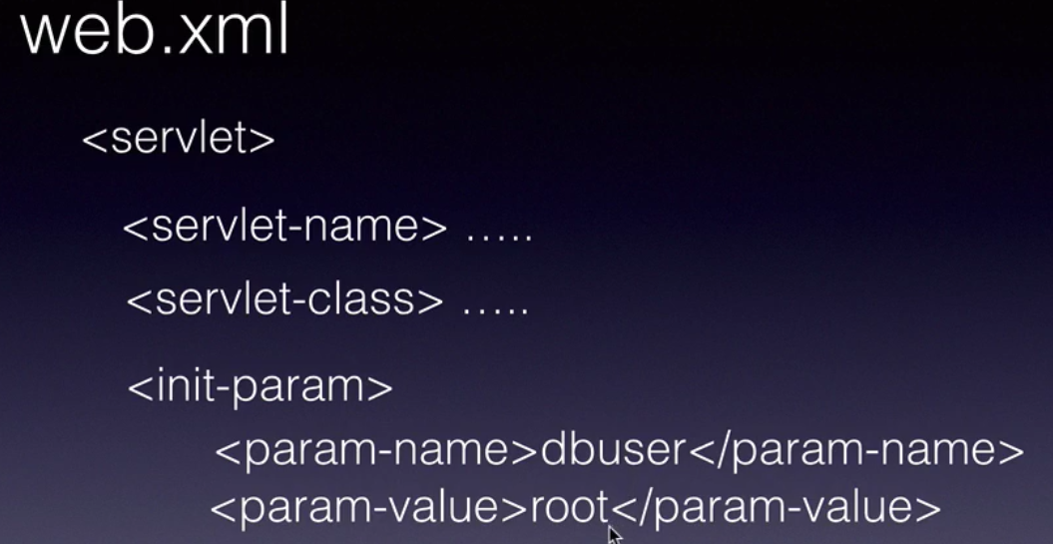

Once you configure the values in the web.xml file, the servlet container will pass the init params to the servlet through the init method.

During the initialization phase, the container will create a ServletConfig object with the init-param information given in web.xml file.

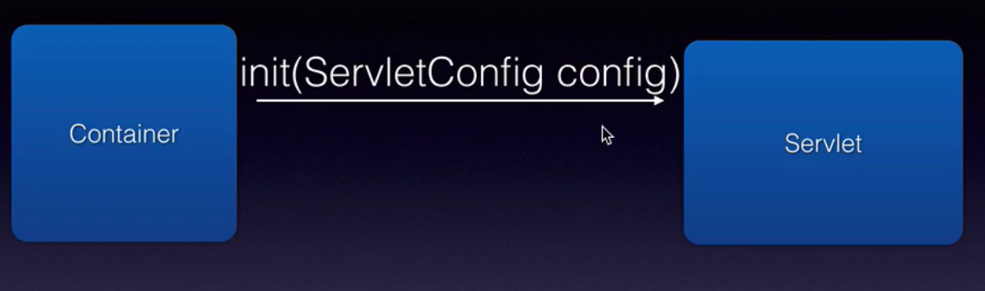

You can configure any number of init-param values in the web.xml file. The advantage is, we don't need to use any hardcoded values.

Configuring init-params using annotations :

@WebServlet(urlPatterns="/addServlet", initParams={ @WebInitParam(name="dbUrl", value="jdbc:mysql://localhost/mylocaldb"), @WebInitParam(name="dbUser", value="root"), @WebInitParam(name="dbPassword", value="chotu123")})

public class CreateUserServlet extends HttpServlet {
private static final long serialVersionUID = 1L;
private Connection connection;

// this gets called ONLY ONCE
public void init(ServletConfig config) {
try {
System.out.println("init");
Class.forName("com.mysql.jdbc.Driver");
connection = DriverManager.getConnection(
config.getInitParameter("dbUrl"),
config.getInitParameter("dbUser"), config.getInitParameter("dbPassword"));
} catch (SQLException e) {
e.printStackTrace();
} catch (ClassNotFoundException e) {
e.printStackTrace();
}
}

......
}

or other way : configuring init-params through web.xml

<servlet>
<servlet-name>ReadUserServlet</servlet-name>
<servlet-class>com.rdayala.user.servlets.ReadUsersServlet</servlet-class>
<init-param>
<param-name>dbUrl</param-name>
<param-value>jdbc:mysql://localhost/mylocaldb</param-value>
</init-param>
<init-param>
<param-name>dbUser</param-name>
<param-value>root</param-value>
</init-param>
<init-param>
<param-name>dbPassword</param-name>
<param-value>chotu123</param-value>
</init-param>
</servlet>

<servlet-mapping>
<servlet-name>ReadUserServlet</servlet-name>
<url-pattern>/readServlet</url-pattern>
</servlet-mapping>

